Section II – Figures

Figure 1: Spectrum s(t)

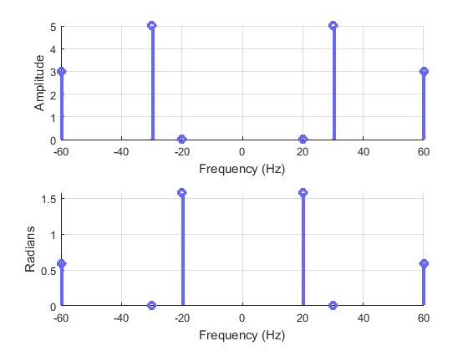

Figure 2: s(t)

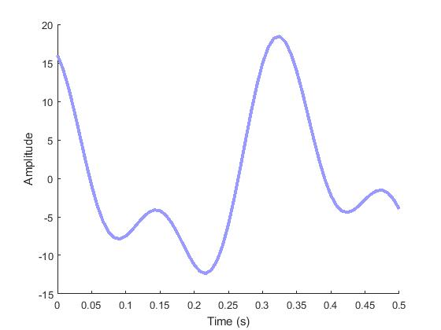

Figure 3: Spectrum s[n]

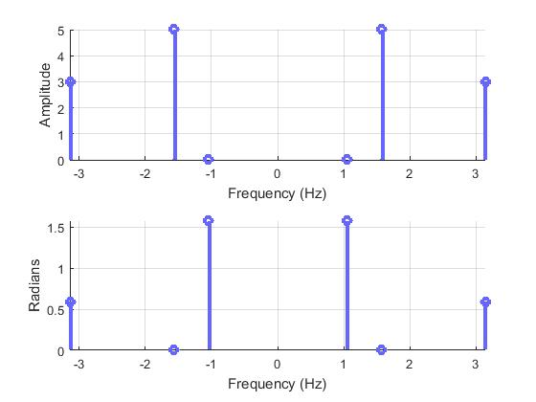

Figure 4: s[n]

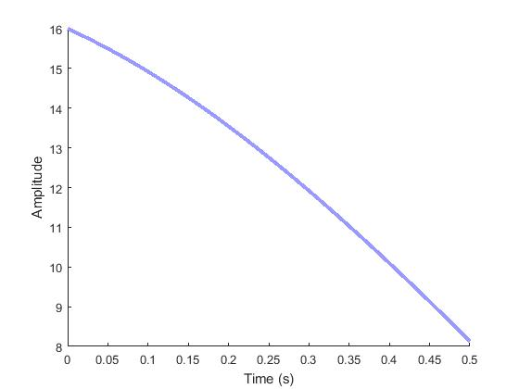

Figure 5: Spectrum of reconstructed s(t)

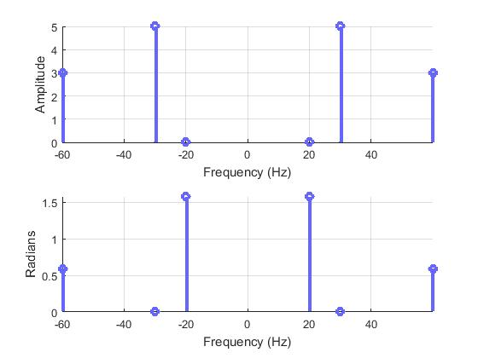

Figure 6: Reconstructed s(t)



Figure 7: Aliased Spectrum s(t)



Figure 8: Aliased s(t)

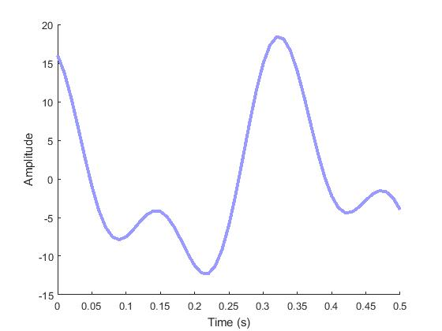

Figure 9: Aliased Spectrum s[n]

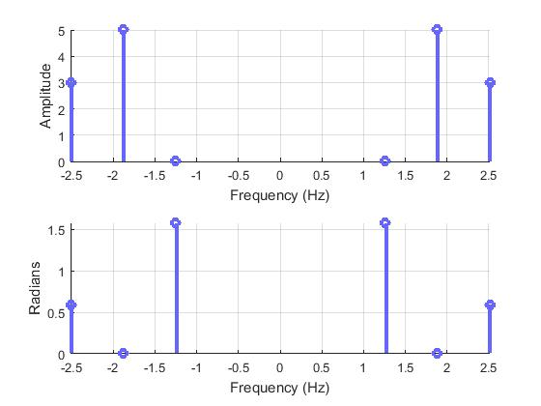

Figure 10: Aliased s[n]

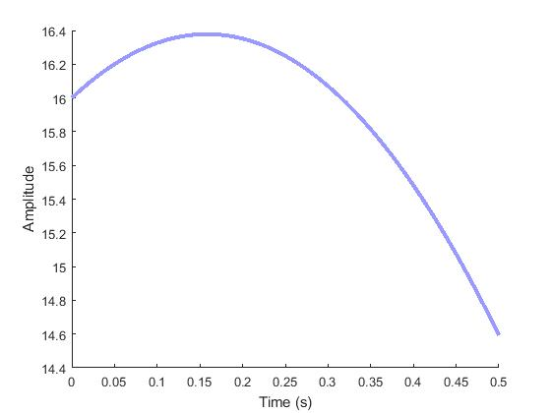

Figure 11: Aliased Spectrum of reconstructed s(t)

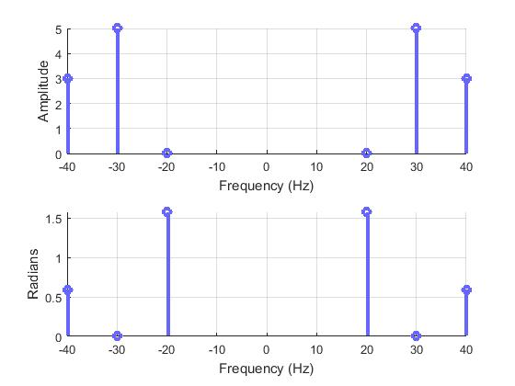

Figure 12: Reconstructed Aliased s(t)

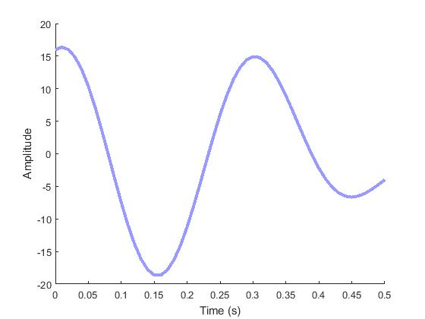

Figure 13: Lowpassed Spectrum s(t)



Figure 14: Lowpassed s(t)



Figure 15: Lowpassed Spectrum s[n]

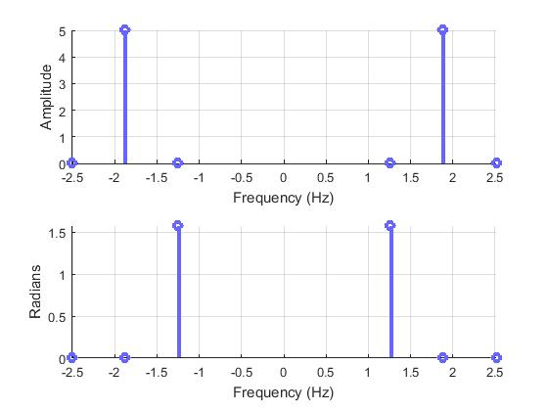

Figure 16: Lowpassed s[n]

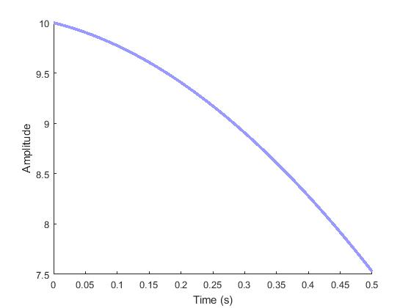

Figure 17: Lowpassed Spectrum of reconstructed s(t)

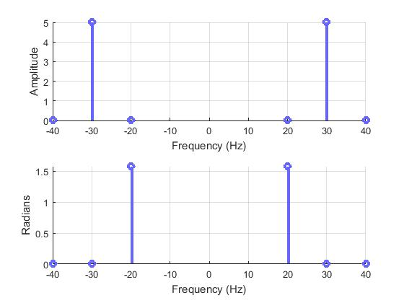

Figure 18: Reconstructed Lowpassed s(t)

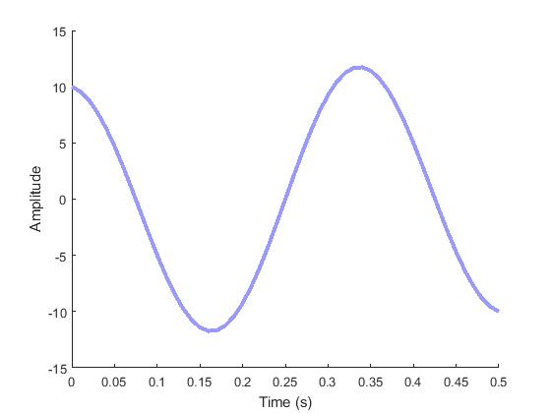

Figure 19: Problem 3 Spectrum s(t)

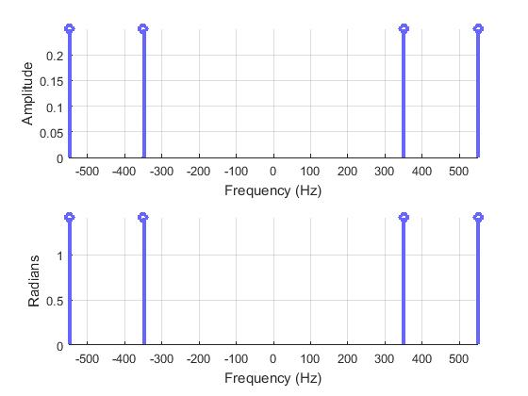

Figure 20: Problem 3 s(t)

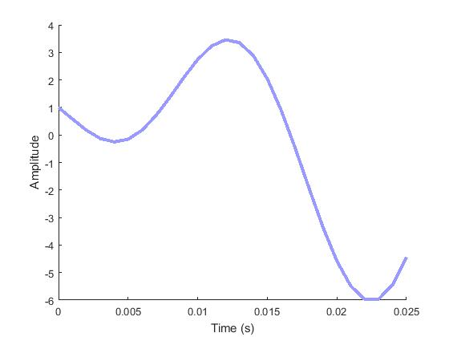

Figure 21: Problem 3 Spectrum s[n]

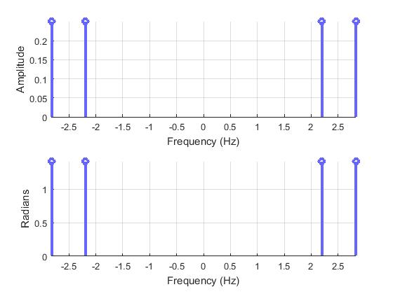

Figure 22: Problem 3 s[n]

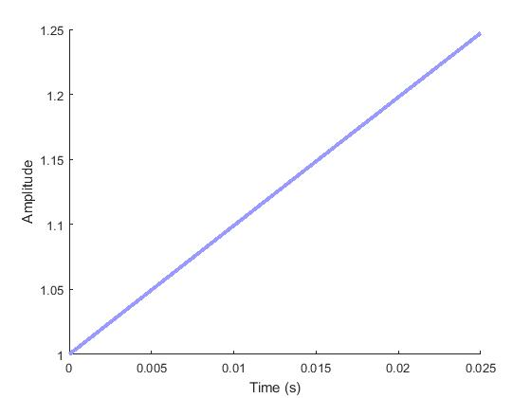

Figure 23: Problem 3 Spectrum of reconstructed s(t)

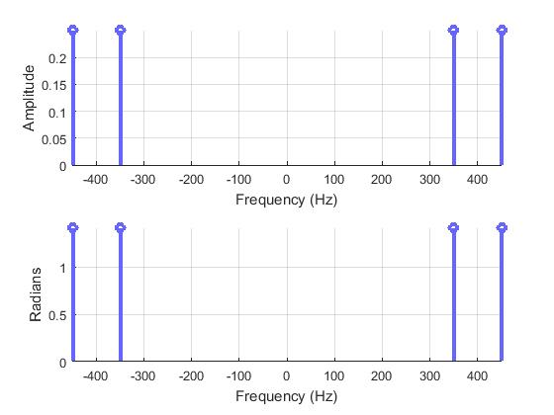

Figure 24: Problem 3 Reconstructed s(t)

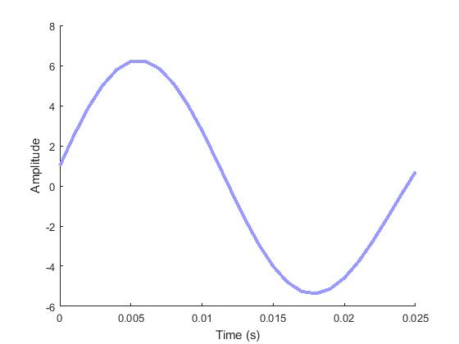

Figure 25: Problem 3: s(t) and reconstructed s(t) (each 10th line is n/fs)

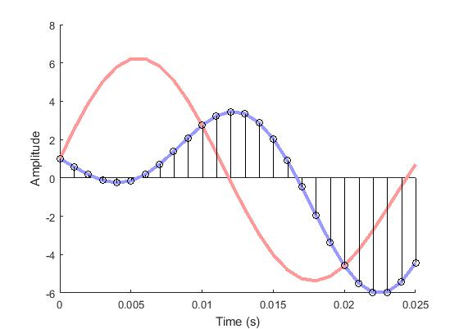

Figure 26: Recorded Audio

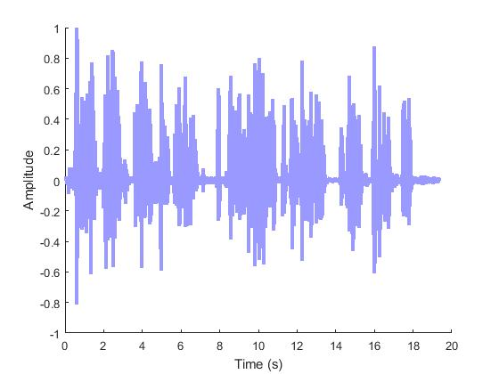

Figure 27: XN1 Added

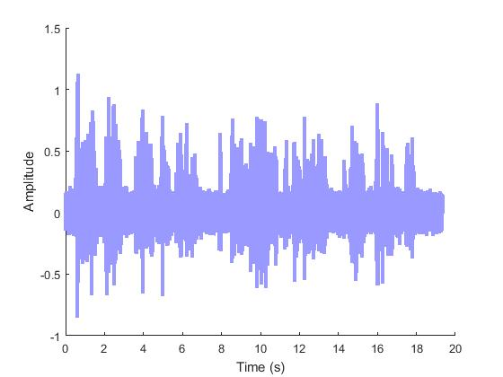

Figure 28: XN2 Added

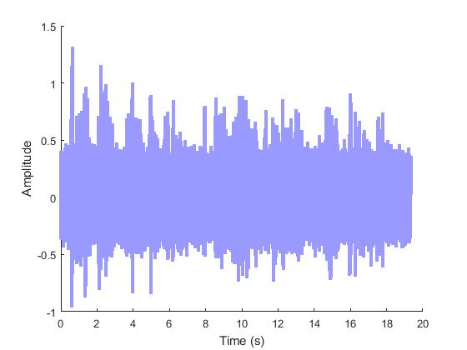

Figure 29: XN1 Denoised with Average Filter

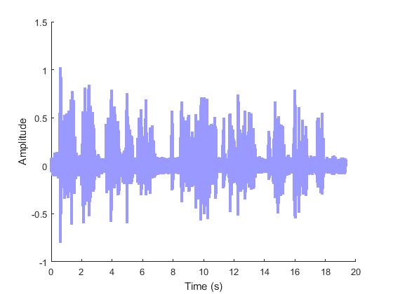

Figure 30: XN2 Denoised with Average Filter

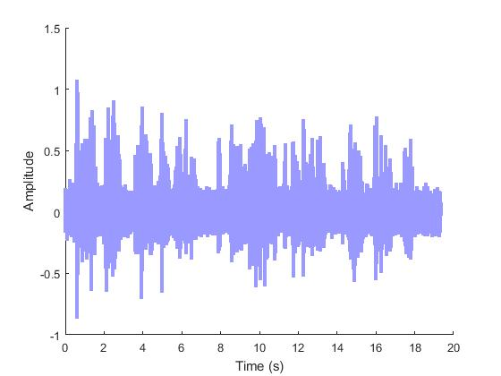

Figure 31: SNR vs. Filter Length

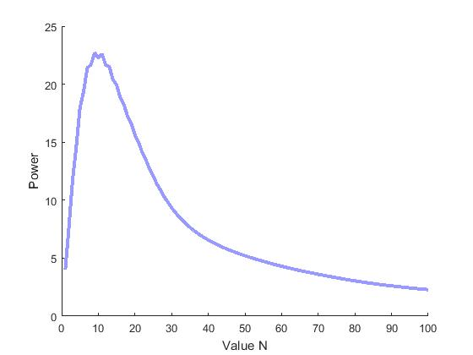

Figure 32: Generated Waveform for 5.1

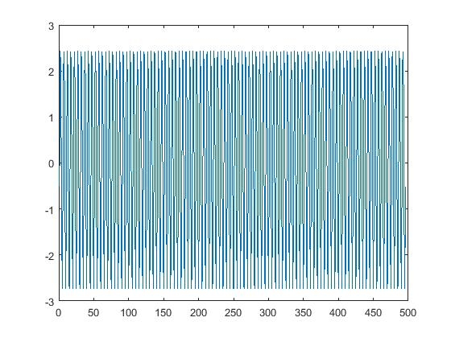

Figure 33: Magnitude V. values w

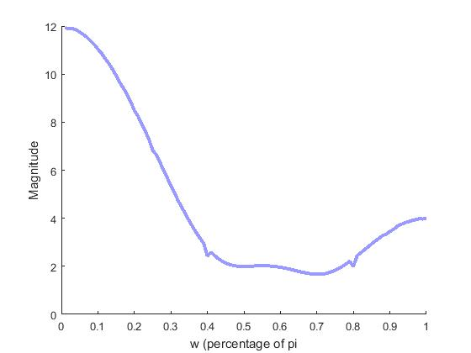

Figure 34: plot of w v. H(w)

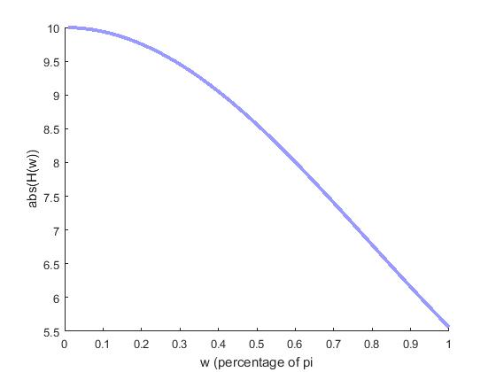

Figure 35: 0 Coefficient FIR filter Results

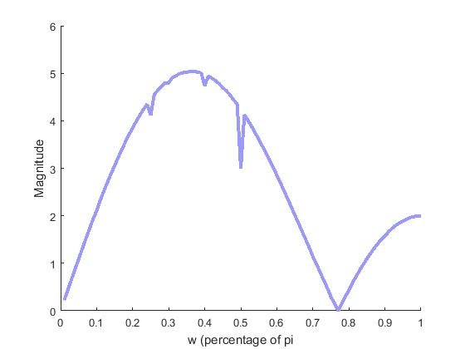

Figure 36: Graph generated with **freqz**



